1. 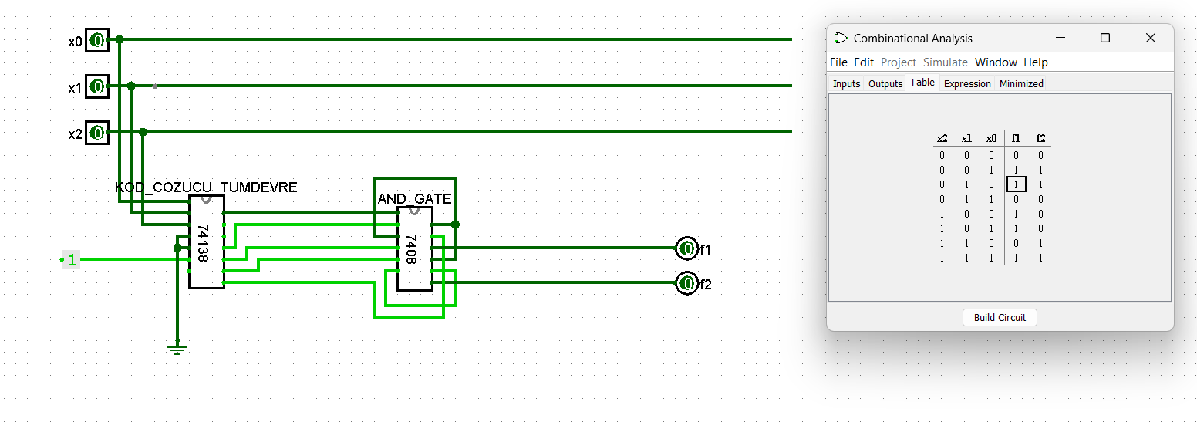Step1
2. Step2

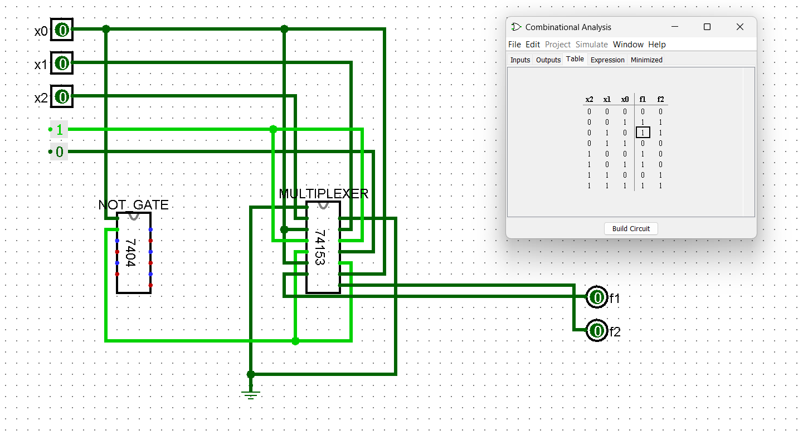

1. Step3

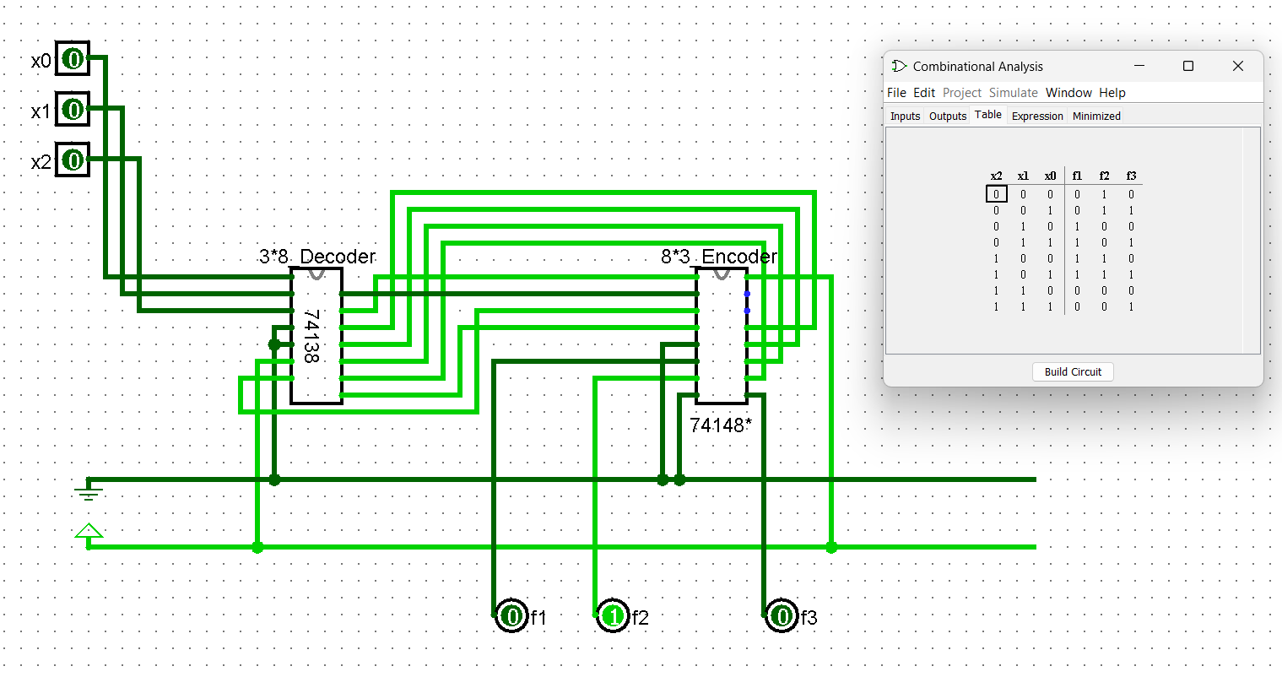

1. **Which logic values do you need to connect to the G input for the 74153 IC to work?  
   Answer by reviewing the datasheet given in the course resources.**

According to the datasheet of the 74153 IC, to enable the device, the G input pins must both be set to logic LOW (0).Therefore, to make the 74153 IC work, you need to connect logic LOW (0) values to the G input pins.

1. **Which logic values do you need to connect to the G2A', G2B' and G1 inputs for the  
   74138 IC to work? Answer by reviewing the datasheets given in the course resources.**

The 74138 IC is a component used to decode and demultiplex 3-to-8 lines. The chip's operation is dependent on the values assigned to its G1, G2A', and G2B' input pins, which must be set to a specific logic state to activate the device. As per the datasheet, to enable the IC, the G2A' and G2B' pins should have a logic LOW (0) value, while the G1 input pin should have a logic HIGH (1) value. Therefore, to make the 74138 IC work, you must connect the corresponding logic values to the respective input pins.

1. **Which logic values should you connect to the G2A', G2B' and G1 inputs on the 74148 IC and for E1? Answer by reviewing the datasheets given in the course resources.**

The 74148 IC is an 8-to-3 line encoder, and its operation is dependent on the values assigned to its input pins and enable input E1. To enable the IC, the E1 input pin must have a logic LOW (0) value. To make the IC work as an encoder, binary inputs must be assigned to the input pins A0 through A7, and the resulting binary code of the active input will be represented by the outputs Y0, Y1, and Y2. Unlike the 74138 IC, the 74148 IC does not have G2A', G2B', and G1 input pins, so there are no corresponding logic values to connect to these pins on the 74148 IC.

1. **What do Active-0 and Active-1 mean?**

Active-0 and Active-1 are two different ways of defining the active state of a logic signal. In an Active-0 system, a logic signal is considered active when it has a value of 0, and it is inactive when it has a value of 1. Conversely, in an Active-1 system, a logic signal is considered active when it has a value of 1, and it is inactive when it has a value of 0.

1. **When 0 0 1 is connected to x0 x1 x2 inputs in step3, what values do you see at the  
   output of the decoder and at the input and output of the encoder?**

When the x2, x1, x0 inputs are given the value of 100, respectively, the circuit outputs as f3,f2,f1 = 011 (encoder output).

Decoder output = 1111_0111

Encoder input = 1111_1101

Encoder output = 011